**SW2 – Project Evaluation Form**

* **Each team must submit the following Documentation that contains:**

**- Project Description in detail.**

**-** **Class Diagram. And** **Database Schema.**

* **Each team must submit the project via GitHub:**
* **Source Code.**
* **Video Demo for running ( 2 – 5 Minutes ).**
* **Documentation and Evaluation Form.**
* **The Evaluation will start with giving all teams 30 marks then check the following criteria:**

**Full violated –**They violate the principle in all cases in the Code.

**Medium Violated –** They apply the principle in some cases and violate it in some cases (in total the student applies the principle on average).

**Small violated –** They Apply the principle in most cases except for a very few cases, no more than one or two.

|  |  |  |  |  |
| --- | --- | --- | --- | --- |
| **Violation Level** | **Full** | **Medium** | **Small** | **Grade** |
| **Documentation** | **-5** | **-2** | **-1** |  |
| **Not Apply MVC (it does not Separate Business logic from GUI).**  **Example of violation: write the implantation for a method such as an inset item into the database inside the Button Action method)** | **-6** | **- 3** | **-1** |  |
| **Violate clean code – Variables** | **-2** | **-1** | **-.05** |  |
| **Violate clean code – Functions** | **-2** | **-1** | **-.05** |  |
| **Violate Single-responsibility Principle** | **-2** | **-1** | **-.05** |  |
| **Violate Open-closed Principle** | **-2** | **-1** | **-.05** |  |
| **Violate the Liskov Substitution Principle** | **-2** | **-1** | **-.05** |  |
| **Violate Interface Segregation Principle** | **-2** | **-1** | **-.05** |  |
| **Violate Dependency Inversion Principle** | **-2** | **-1** | **-.05** |  |
| **Not Upload code to GitHub** | **-1** | | |  |
| **Only One Branch Without Merge (GitHub)** | **-2** | | |  |
| **Only One Contribution (GitHub)** | **-2** | | |  |
| **Total Minus from Grade** |  |  |  |  |

|  |  |  |
| --- | --- | --- |
| **Design Pattern Bounce** | **+4** |  |
| **Bounce on Overall Work** | **+2** |  |
| **Total Team Grade / 30** |  | |

|  |  |  |  |
| --- | --- | --- | --- |
| **Name (Arabic)** | **ID** | **Individual Bounce +2** | **Grade** |
| **رانيا خالد جابر عبد التواب محمد** | **201900293** |  |  |
| **رنا عادل فرج احمد الراشدي** | **201900206** |  |  |
| **سمية شريف محمد محمد** | **201800355** |  |  |
| **رضوى عبدالله محمد احمد** | **201900300** |  |  |
| **سلمى ناصر محمد احمد** | **201900351** |  |  |
|  |  |  |  |
|  |  |  |  |

**Project Description**

**Documentation of Car Rental System**

CAR RENTAL SYSTEM is a web-based system for a company that rents out cars.

**Objectives:**

**The main objectives of this project are:**

-To develop a web-based system that will help manage the business transactions of car renting.

-To help in advertising the car rental services of a company, through the availability of the system online.

## ****Scope:****

**The scope of this project is as follows:**

-The car rental system to keep detailed records of both the cars and the customers, the duration they rent a car as well as the type of car they rent.

-The system will be mainly designed for small a company that renders its car rental services to customers.

-The system will have the ability to generate and print invoices for each successful transaction.

**Level of Access:**

**The system will have one level of access:**

- The administrator

## ****Software development tools****

**The project will make use of the tools:**

-The programming language to use will be C# .Net Using MVC.

-SQL server will be used for the development of the database

**Description:**

**First:** admin will Login With His Email And Password to allow to add car or customer ,rent a car and return car again **.**

**Second: if admin select:**

1. car

it make admin can add a car then can edit, delete, or show details about a car

1. customer

it make admin can add new customer then can edit, delete, or show details about a customer

1. rent to rent a car and make it not available

it get information about a car that admin enter its car number and make admin selected rentail fee and save it

1. return car to return a car and make it available again to rent by customer

**Design Pattern**

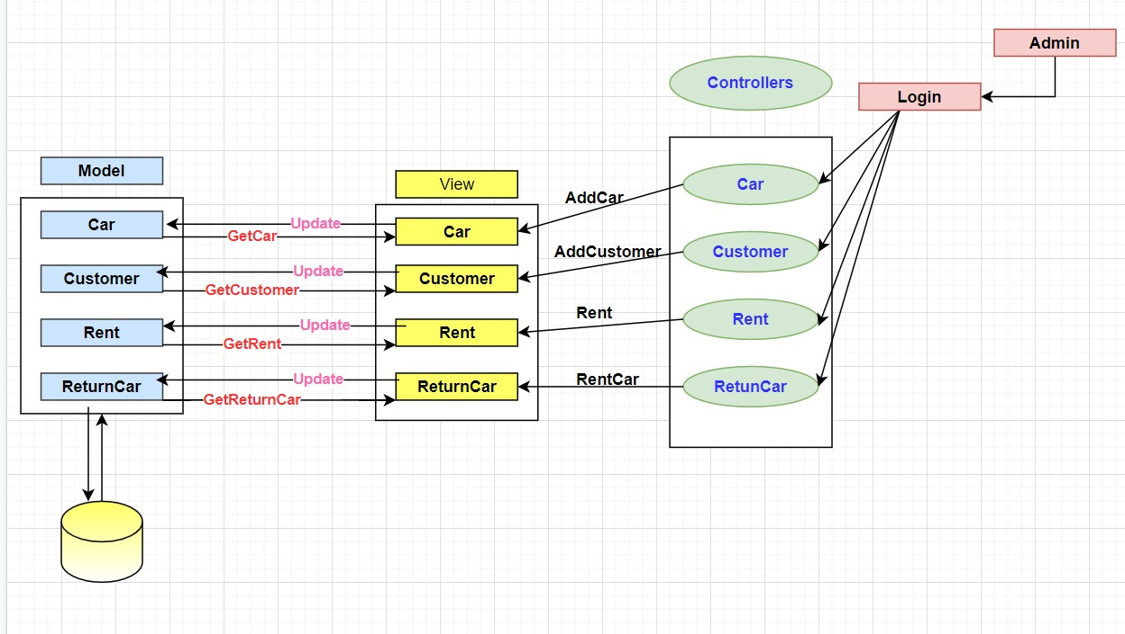

**Database Schema**

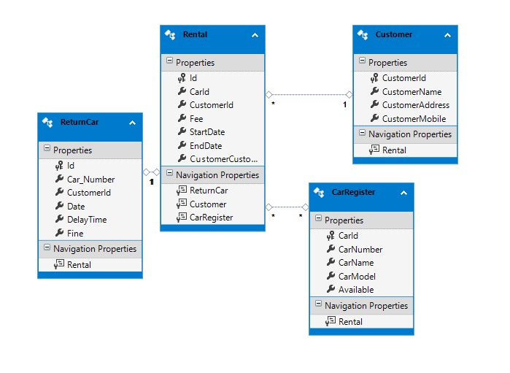

**Class Diagram**

